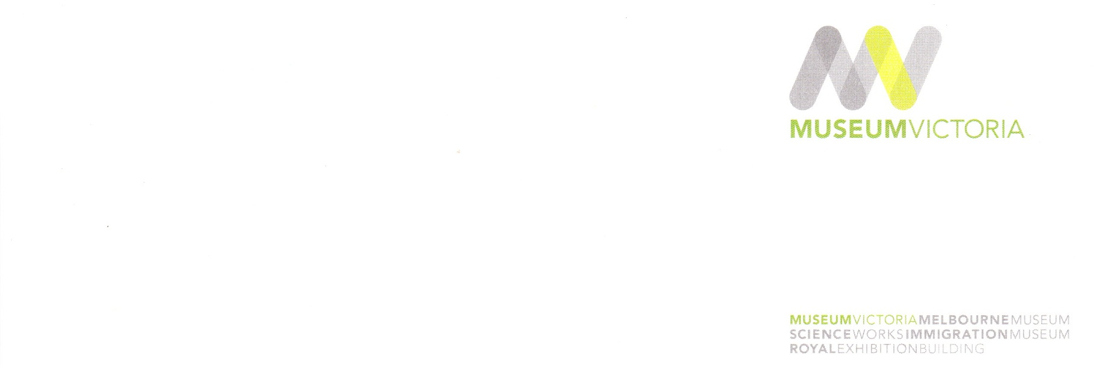

Department of Fish and Game

License and Revenue Branch

1740 North Market Boulevard

Sacramento, CA 95834

Dear James Fong:

On 7 December 2012 I received a letter requesting I provide a Scientific Collecting Report of Specimens Captured or Salvaged Form (FG1379a) for my Scientific Collecting Permit (SC-10145), issued 17 August 2010. During the time in which the permit was valid, I did not collect any specimens under the authority of this permit. I have included a copy of the report with my contact details and a statement to this effect.

If further information is required in relation to this permit, I can be reached via the contact details below. My apologies for the delay in providing the information within the required time frame.

Sincerely,

Karen Rowe, Ph.D.

Ian Potter-Williamson Biodiversity Research Fellow  
Museum Victoria  
GPO Box 666  
Melbourne, VIC 3001  
AUSTRALIA  
ph: +61 (03) 8341 7424  
fax: +61 (03) 8341 7442  
karowe@museum.vic.gov.au